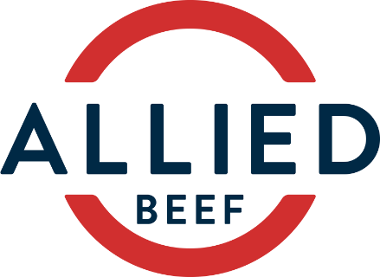

**MANAGER**

**Central Queensland**

Allied Beef is one of Australia’s premium supply chain management companies. The company primarily produces and markets cattle in Queensland and New South Wales. Currently we have an exciting opportunity for a new team leader to take up the position of Manager at a 10,000 head feedlot in Central Queensland, located near Springsure.

The successful applicant will be responsible for the day to day management of the operations with a focus on production and people management. Your leadership will be instrumental in fostering an efficient and safe work environment while ensuring best practice in feeding, cattle care and facility maintenance.

The applicant should have

* Leadership qualities;
* Ability to lead and be part of a small team;
* Knowledge of feedlot and general cattle operations;
* Knowledge of commodity markets;
* Excellent organisational and communication skills; and
* Ability to assist in cattle marketing and procurement.

Join our team in this senior management role and become part of our progressive beef company. An attractive remuneration package, dependent on skills and experience, will be negotiated with the successful applicant.

If you wish to pursue a rewarding career with a progressive company, contact James Maclean [jmaclean@alliedbeef.com.au](mailto:jmaclean@alliedbeef.com.au) or 0437 554 658.

Full confidentiality will be maintained