The true goal is “Climate Neutral”, not “Carbon Neutral”

Unfortunately, climate policy doesn’t always align with how the natural world functions. Somehow the goal has now become Carbon Neutral, when the goal was Climate Neutral with the 2015 Paris Climate Agreement.
“The Paris Agreement is a legally binding international treaty on climate change. It was adopted by 196 Parties at COP 21 in Paris, on 12 December 2015 and entered into force on 4 November 2016.
Its goal is to limit global warming to well below 2, preferably to 1.5 degrees Celsius, compared to pre-industrial levels. To achieve this long-term temperature goal, countries aim to reach global peaking of greenhouse gas emissions as soon as possible to achieve a climate neutral world by mid-century.”

The above wording is on the UN web site at the start of this link: https://unfccc.int/process-and-meetings/the-paris-agreement/the-paris-agreement.

When it comes to climate stabilisation (Climate Neutral), climate scientists have long understood that using the GWP 100 metric, for calculating the contribution to temperature change by the different greenhouse gases, is not fit for purpose. Carbon Neutral is based on GWP100 which is using accepted science in a context that no longer applies. The outcome of using flawed accounting for temperature change, is that it shifts emphasis and encourages decisions that move the world towards 2 degrees of warming faster. As an example, GWP100 says that a reduction in ongoing stable methane emissions from cattle will still result in temperature rise, when this action actually produces global cooling.

To understand what has to be done to deal with climate change, we first have to understand what radiative forcing is. The warming effect of each greenhouse gas is known and is referred to as "radiative forcing" and is measured as watts per cubic metre of gas. Stabilising the climate (Climate Neutral) relies on stabilising the total radiative forcing of all the greenhouse gases in the atmosphere.

There are two broad classes of emissions:
- Long-lived greenhouse gases, like carbon dioxide, which persist in the atmosphere and build up over centuries.
- Short-lived lived greenhouse gases, like methane, which disappear within about 12 years. These short-term gases are sometimes referred to as short-lived climate pollutants (SLCPs).

The difference in outcome between Climate Neutral and Carbon Neutral comes down to how short-term gases like methane are treated.

The problem with GWP100 is how it compares these long-term and short-term gases in relation to climate stabilisation. With methane, the GWP100 metric is producing incorrect results in terms of the change to radiative forcing with ongoing stable methane emissions from ruminant livestock. GWP* was developed recently to address these shortcomings.

The discussion that follows will demonstrate that methane from ruminant livestock is a flow gas and does not accumulate in the atmosphere; in contrast CO2 emitted from fossil fuels is a stock gas and accumulates. When the goal is Climate Neutral, GWP100 is not fit for purpose because it treats methane as a stock gas - when it is not accumulating.

Ongoing stable methane emissions from cattle reach equilibrium
The best way to understand the diagram of the cow below is to visualise methane constantly being released by the cow and accumulating above it (in the green circle). While the cow is releasing methane, past emissions will be breaking down in the atmosphere at the same rate. Methane lasts 12 years in the atmosphere (some suggest shorter), before being broken down into CO₂ and H₂O. It is broken down by a chemical reaction with hydroxyl radicals (OH) that keep forming in the atmosphere. Assuming the methane released by the cow each year is the same, then the methane residing in the atmosphere (green circle) will be in equilibrium, with the additions and subtractions. It is true that cow size and pasture quality determines the amount of methane released, however, the fact the cow changes size and eats a different diet over time is a variable which averages out over time.
This circle represents atmospheric equilibrium.
The equilibrium level equals 12 years’ emissions
Ongoing stable methane emissions from cattle do not change the net balance of greenhouse gases i.e. not changing the climate
Ongoing methane
Further explanation of wording on the left

The green circle could represent a paddock, a property or a country.

The equilibrium continues with the next cow put in the paddock and, all that follow.

This exercise only refers to agricultural emissions. Fossil methane (CH₄) emissions are putting "New" CO₂ into the atmosphere when the CH₄ breaks down.

In the atmosphere, methane breaks down after 12 years into CO₂ and H₂O. Equilibrium is reached because CH₄ is a short term gas that is chemically reactive.

Provided the emissions have been stable for a few decades, stable methane emissions do not change the net balance of greenhouse gases, i.e. don’t change radiative forcing.

With the reference to not changing the climate, the stability period has to be some decades more because, with all greenhouse gases, CO₂ included, there is “committed warming”, which means some of the effect of past emissions is still to come because of the thermal inertia of the earth’s oceans.

Methane emissions from sheep and cattle in Australia peaked in the 1970’s, so are not contributing to climate change because the required period for stability and committed warming is covered.

Given CO₂ accumulates, while methane does not, if methane from sheep and cattle are capped at today’s rate, this is the same as cutting CO₂ emissions to zero.

Methane keeps breaking down into CO₂ and H₂O
not change the net balance of greenhouse gases i.e. not changing the climate because they are not adding to “radiative forcing”.
In the cow and green circle diagram, think of the equilibrium amount of methane, as a permanent balloon of methane that follows the cow around every day. When the cow is sent to the meat works and replaced by another cow, the balloon follows the next cow that is put in the paddock. In fact, all the cows that follow for the next 500 years.
The cow and its replacements will be producing methane permanently, however, at the end of the life cycle of the methane, what is produced in the first year of the new cycle, will only be replacing the first year in the previous cycle, which will now be gone. Methane is not an accumulating gas like carbon dioxide is.
Carbon dioxide (CO₂) is a stock gas while methane (CH₄) is a flow gas

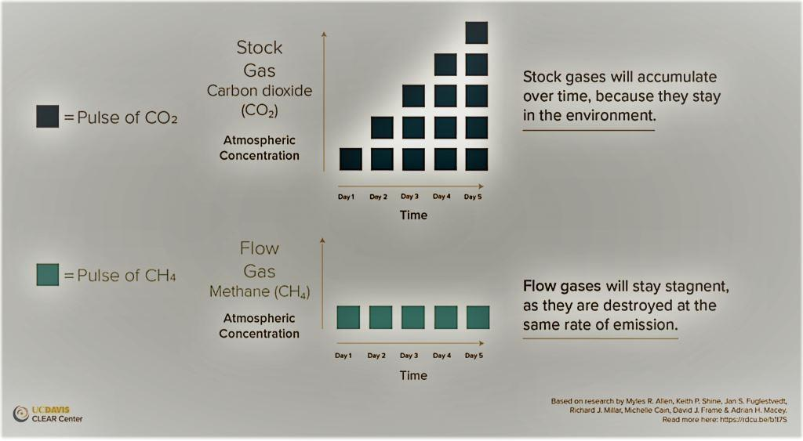

Methane from ruminant livestock is a flow gas and does not accumulate in the atmosphere; in contrast CO2 emitted from fossil fuels is a stock gas and accumulates. Source: UC Davis CLEAR Centre.

In the graph, Pulse refers a one-off release into the atmosphere. Ongoing pulses of carbon dioxide further changes the climate, while ongoing pulses of methane consistent with previous years, does not further change the climate and is consistent with the goal of Climate Neutral.
The graph reaches the same conclusion as the cow and balloon diagram.
“According to ISO 14021 (ISO, 2016), the term “carbon neutral” can be used when a carbon footprint (which assesses all GHG emissions and removals using GWP100) is zero or when it has been completely offset. That said, more broadly, carbon neutral ruminant livestock production can only be achieved with large scale offsetting.

As such, the need for ruminant livestock production systems to widely pursue a carbon neutral strategy, where all GHG emissions are reduced to zero or offset, should be questioned.” (Ridoudtt)

The GWP100 approach is defined for one-off emissions

The GWP100 approach focuses on one-off emissions and compares a one-off emission of methane to a one-off emission of carbon dioxide. GWP100 is emission equivalence accounting where all greenhouse gases are quantified in terms of CO₂ equivalence, termed CO₂-e emissions.
The GWP100 has become a default climate metric. Its introduction by IPCC was originally intended to illustrate the difficulties and limitations of any metric designed to aggregate the climate impacts of CO2 and non-CO2 greenhouse gases.
In 2013, the peer reviewed paper “Offsetting methane emissions – An alternative to emission equivalence metrics” (Lauder et al) was published in the “International Journal of Greenhouse Gas Control”.

The Abstract states:
We argue that a more appropriate way to consider the relationship between the warming effects of methane and carbon dioxide is to define a ‘mixed metric’ that compares ongoing methane emissions (or reductions) to one-off emissions (or reductions) of carbon dioxide. Quantifying this approach, we propose that a one-off sequestration of 1 t of carbon would offset an ongoing methane emission in the range 0.90–1.05 kg CH₄ per year. Our analysis is consistent with other approaches to addressing the criticisms of GWP-based emission equivalence.

The offset equation is very relevant to a producer who wants to increase cattle numbers (increase ongoing methane emissions) and still be climate neutral.

If producers want to increase cattle numbers over the long term average, then they have to store carbon in the paddock to offset the increased ongoing methane emissions (increased radiative forcing) and still be Climate Neutral.

With the offset equation, the carbon has to be sequestered (stored) in the paddock over a 40-year period.

The paper highlights that with ruminant livestock methane, a steady emissions profile over time can be consistent with climate stabilization.

Myles Allen of Oxford University and his group picked up on the thinking in this paper and came up with GWP* in 2018 to deal with the anomalies produced by GWP100.

GWP* proposed as an alternative to GWP100

The need to better articulate the diverse climate impacts of short and long-lived climate forcers has underpinned the recent development of a new climate metric, the GWP* (Allen et al., 2018).
The GWP* climate metric assesses the future warming associated with a permanent change in the rate of emission of a short-lived climate forcer. In order to quantify the change, emissions need to be assessed over a time interval. The developers of GWP* use a 20-year time interval, arguing that this smooths out short-term fluctuations in emission rates that may not reflect permanent change (Allen et al., 2018).

The GWP* climate metric has been developed to describe the future warming associated with a change in rate of emission of a short-lived climate forcer, like methane, compared to a pulse emission of CO₂, a long-lived climate forcer. This metric can be used to guide climate action aligned with temperature-based climate stabilization goals, as expressed in the Paris Agreement.

With the GWP* metric, methane emissions need to be reduced by 0.3% each year to stabilise warming. The offset equation in Lauder et al could be used to cover the small 0.3% reduction required.

This new metric is especially relevant for use in industries where short-lived GHG emissions, like methane, are important.

IPCC acknowledges there are alternatives to GWP100

The IPCC has long acknowledged that there are alternatives to GWP100. The most recent IPCC Assessment (IPCC AR6 WGI, Chapter 7, page 122) states:

“Global surface temperature changes following a pulse of CO₂ emissions are roughly constant in time whereas the temperature change following a pulse of short- lived greenhouse gas emissions declines with time. In contrast to a one-off pulse, a step change in short-lived greenhouse gas emissions that is maintained indefinitely causes a concentration increase that eventually equilibrates to a steady state in a way that is more comparable to a pulse of CO₂. Similarly the resulting change in global surface temperature from a step change in short-lived greenhouse gases (Figure 7.21a) after a few decades increases only slowly (due to accumulation of heat in the deep ocean) and hence its effects are more similar to a pulse of CO₂ (Smith et al 2012; Lauder et al 2013; Allen et al 2016, 2018b).”

What the IPCC is saying here, summarises the points being made in this discussion.

Atmospheric scientist’s summary

“Given that CO2 persists in the atmosphere over centuries to millennia and hence accumulates over time, net CO2 emissions must drop to zero for temperature to stabilize, and additional warming will occur until that condition is reached. By contrast, CH4 has an atmospheric lifetime of approximately 12 years and emissions do not accumulate over centuries; hence, even a very moderate reduction of global CH4 emissions at a rate of about 0.3% per year would stabilize warming from CH4 at approximately current levels. These different temperature outcomes have led some authors to argue that expressing CH4 emissions as ‘CO2-equivalent’ emissions based on the common 100-year Global Warming Potential (GWP100) is misleading and dangerous as it could misdirect attention from the need to reduce global net CO2 emissions to zero as quickly as possible. These concerns have led some to maintain that deep reductions of agricultural CH4 emissions are not necessary to support ambitious climate action. This view is further supported by an interpretation that slowly declining CH4 emissions already represent climate neutrality, given that this would not result in additional warming compared to the present.
While the need to reduce the dominant, long-lived greenhouse gas CO2 to zero is unambiguous, the same does not apply to CH4, owing to the different lifetimes of these gases and temperature response to their emissions.” (Reisinger)

Better management of carbon flows shifts producers towards Climate Neutral

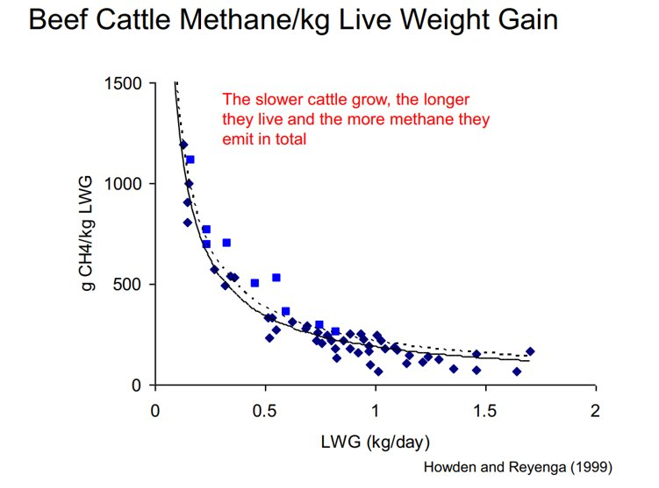
What this graph is saying is that production systems that increase cattle growth and get them to market sooner, produce less methane per kg of production.
Changing management to increase the amount of carbon flowing through the paddock, increases the digestibility of the diet available to cattle, by changing the carbon:nitrogen ratio of their diet. Improving the diet of cattle reduces the amount of methane produced per kg of beef, because they grow faster and go to the meatworks sooner. This explains why applying the Carbon Grazing principle helps move beef production towards Climate Neutral.
This drop in methane results in reduced radiative forcing which offsets CO2 emissions on the way to being Climate Neutral.
The discussion to this point demonstrates that many cattle producers are closer to being Climate Neutral than they realise. For those producers who have had stable methane emissions for some time, to make the claim of climate neutrality, they only have to look into their carbon dioxide and nitrous oxide emissions and investigate if any storage of carbon in their landscape offsets these two emissions.

With producers who have reduced their ongoing methane emissions, through reduced cattle numbers or better pasture management, this reduction will act as an offset towards carbon dioxide and nitrous oxide emissions to achieve climate neutrality.

It is often suggested that we need to shift to a plant-based diet to stabilise the climate. However, this is simplistic, and overlooks the need to consider changes in soil carbon levels with the shift from grazing to cropping. “A second challenge is that soil carbon stocks under pastures are generally high, and shifts to cropland result in a period of CO₂ emissions.” (Reisinger).

Conclusion
The concept of CO2-e emissions based on GWP100 is deeply embedded in climate policy in spite of long-standing criticism of its application to SLCPs like methane.

Carbon neutral is based on CO2-e defined in terms of GWP100 which gives a poor indicator of what is required to achieve temperature stabilisation.

Climate neutral, as expressed through metrics such as GWP*, captures the actual changes in the radiative forcing that drives climate change.

Any ongoing releases of CO2 are continually increasing the radiative imbalance of the atmosphere, while ongoing releases of methane at a constant level leave the balance unchanged.

Under GWP100, using methane reductions as an alternative to CO2 reductions is a quick fix with long term detrimental consequences. In 2000 Jim Hansen suggested that reducing CH4 quickly is a useful thing to do IF (and by implication ONLY IF) you stop the growth in CO2 emissions.

