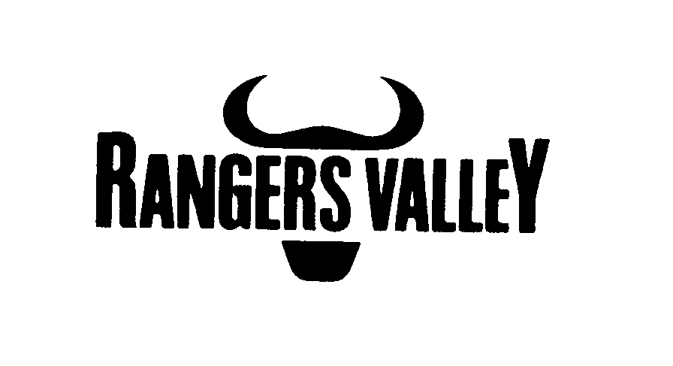

Rangers Valley Feedlot, on the Northern Tablelands of NSW, specialises in the production of high quality longfed beef. The operation combines a 33,000 head cattle feedlot, backgrounding and farming operation.

Several fulltime positions working on a roster have become available.

Feedlot Maintenance Position

This is a full time position reporting to the workshop supervisor with the key duties being;
- Maintenance, repairs and upgrades of feedlot water infrastructure
- Cattle handling yard and pen repairs
- Fabrication

The necessary skills required for this position are;
- Sound ability to weld
- Sound ability to use oxyacetylene equipment
- Concreting experience
- Ability to design and construct various projects
- Drivers license
Experience in carpentry will be an advantage.

Pen Rider

Key duties include, but are not limited to;
Pen riding monitoring cattle health, administration of animal health products, cattle handling (foot and horses), processing cattle, cleaning and maintenance of water troughs, computer record keeping, and quality control.

Applicants must be able to competently ride, supply own horses and tack.
Will suit a person interested in intensive cattle production.

Successful applicants will be motivated self-starters, be able to work within a crew, have the ability to work under instruction and be prepared to work hard.
Experience is an advantage but a positive attitude is essential.

Applications to smitha@rangersvalley.com.au

For further information please contact the Assistant Manager on 02 67344000 or email smitha@rangersvalley.com.au

