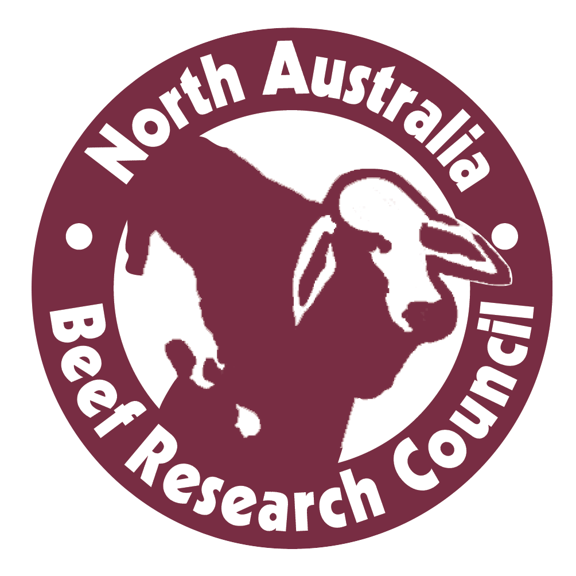

MEDIA RELEASE 17 August 2016

Dr Brian Burns receives NABRC Medal for beef R&D

A life time commitment to beef research and development to benefit the northern beef industry has been recognised, with Dr Brian Burns awarded the 2016 NABRC Scientist / Researcher Medal.

Dr Burns, a University of Queensland Senior Research Fellow, has contributed to the northern cattle industry through more than 30 years’ work in the fields of beef cattle genetics, genomics, epigenetics, animal breeding and reproduction.

North Australia Beef Research Council chairman Dr Lee Fitzpatrick said Dr Burns was a fitting recipient, having an outstanding reputation among scientists and producers for the quality of his scientific research.

“His work has involved evaluations of mainly tropically adapted breeds managed under semi-extensive and extensive grazing conditions, as well as precision beef cattle production systems to assist tropical breeds in adapting to a changing climate,” Dr Fitzpatrick said.

“His research has made a real difference to the profitability of the northern industry and he has worked tirelessly with producers to ensure his research results have been applied in the field.”

Dr Burns was among an elite group of four industry figures recognised by the North Australia Beef Research Council (NABRC) at its awards dinner in Rockhampton last night, where the NABRC Medals were presented by CQUniversity Deputy Vice Chancellor Research, Professor Grant Stanley.

Northern Territory cattleman Keith Holzwart, ‘Avago Station’, Daly Waters , was awarded the 2016 NABRC Producer Medal; Ashley Kirk, of Rockley Brahmans, Bajool, received the 2016 NABRC Young Achiever Medal; and respected Queensland Department of Agriculture extension officer, Ken Murphy, Rockhampton, was awarded the 2016 NABRC Communicator/Extension Medal.

“The NABRC Medals are designed to highlight the achievements of people who have achieved excellence in the fields of production, research and development and communication in North Australia, and Keith, Ashley and Ken are indeed extremely worthy recipients,” Dr Fitzpatrick said.

“In the case of Keith and Ashley, they have been leaders in adopting new practices on their properties, and together with Ken they have encouraged countless others to follow suit, to engage with the research community and apply new knowledge and methods to their businesses.”

NABRC is an alliance of beef producers, research, development and extension providers and funders operating across the Northern Territory, Queensland, and the Pilbara/Kimberly regions of Western Australia.

It provides a forum to identify priority issues facing the north Australian beef industry, it establishes strategic and project-based partnerships, and promotes priority issues for addressing by the RD&E providers.

The dinner was a highlight of the three-day Northern Beef Research Update Conference being held in Rockhampton, where more than 270 producers, researchers and industry figures have gathered.

Sponsored by CQUniversity, the dinner featured beef from Brahman steers that were fed for 70 days on grain at Nolan Meats Wide Bay Feedlot near Gympie and processed at Nolan Meats plant at Gympie.

The NBRUC conference will conclude tomorrow, Thursday August 18, with a tour of CQUniversity’s beef research activities at Belmont Research Station.

- The full conference program is available at www.nbruc.com.au

Ends

Media contact: Michael Thomson, 0408 819 666

