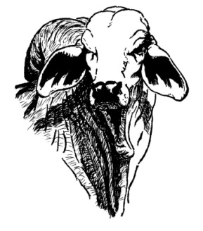

# **N**ORTHERN **V**ETERINARY **S**ERVICES