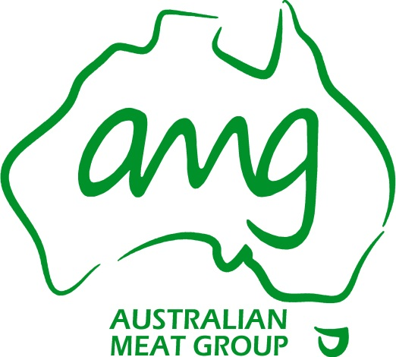

**GENERAL MANAGER /PLANT MANAGER – DANDENONG**

We are a new, Australian owned meat processing facility about to start operations in both Dandenong and Deniliquin NSW.

Run by the former executives of the Tasman Meat Group, the business is a start-up business with revenues expected to be in excess $200M within 2 years, employing over 400 staff.

The Dandenong processing facility has undergone a major transformation, and is now equipped with the latest state of the art facilities. Our facility will operate 6 days per week, and will process approximately 750 cattle per shift for export overseas.

**About the role**

As part of this new exciting journey, we are looking for an experienced General Manager to join us at our Dandenong site, who can take the reins and is capable to deal with all aspects of running an efficient and profitable operation.

You will have responsibility for managing and coordinating the activity of the plant to optimise resource use, minimise costs and maintain quality standards ensuring that our processes are fully compliant with the international market.

To be successful in this role, you will be an experienced General Manager/ Plant Manager who can use initiative and leadership to develop staff and drive continuous improvement. You need to be able to back yourself and be solutions focused. A high level of energy and a positive ‘can do’ attitude will ensure that the Plant is running at its optimum and meeting financial targets.

**Experience and skills required**

* Extensive Plant Management experience with a meat processing facility;
* Comprehensive knowledge of relevant legislation, business practices, processes and procedures as they relate to a meat processing facility;
* Business acumen and financial management knowledge;
* Proven experience managing operation costs and P&L;
* Ability to develop, lead, coach and motivate and inspire a high performing team;
* Negotiation and influencing skills;
* Innovation and continuous improvement focused;
* Strong communication skills;
* Demonstrate and role model the leadership behaviours in the interactions with the team and stakeholders

You will be joining our business at an exciting time, and will be rewarded with a challenging and fulfilling role, and a generous salary package, commensurate with experience.

To apply for this exciting and challenging role, please email your CV to [employment@amg.com.au](mailto:employment@amg.com.au) together with a cover letter detailing your experience.

For any confidential enquiries, please contact Genevieve on 0429 048 352.