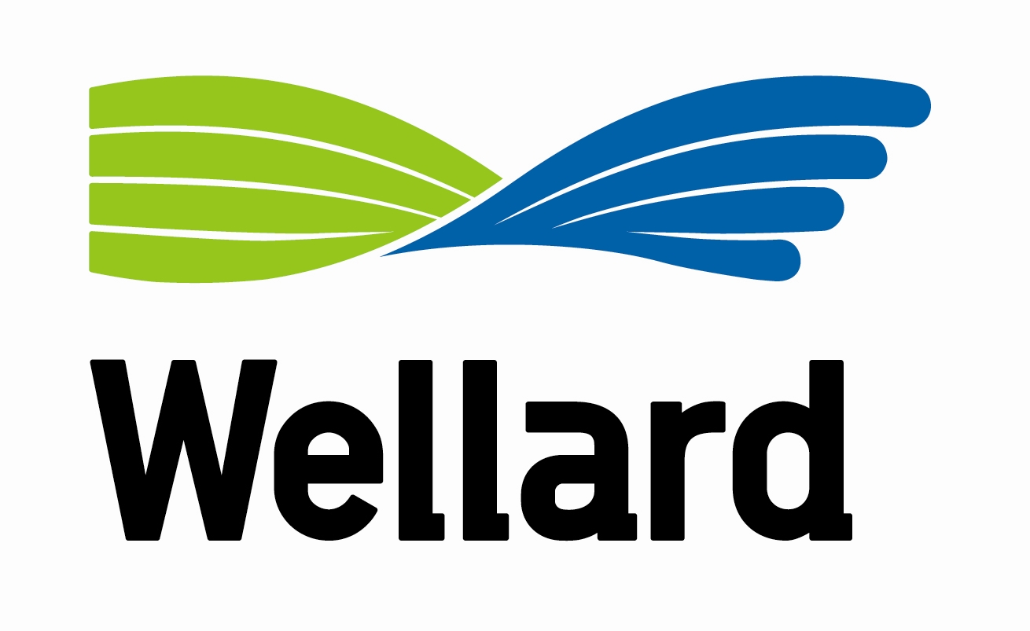

**Farm Manager**

As one of the world’s leading livestock exporters and a global agribusiness, the Wellard Group is committed to excellence in the export and processing of livestock.

An opportunity exists to become part of our livestock export operations. Wellard Rural Exports is seeking a full time employee to manage the day-to-day operations of the property in south-western Victoria. This position reports to an interstate Operations Manager and will include periods of intense cattle backgrounding.

**Position & Responsibilities**

* Management of livestock handling, preparation and movements including receivals, load-outs and processing;
* Management and coordination of day-to-day operational activities of the property outside of the direct livestock activities;
* Management and coordination of staff including rostering and recruitment.

**Candidate**

* Well-developed knowledge of intensive livestock husbandry and handling;
* Strong logistics management and problem solving skills;
* Proven ability to manage and coordinate staff;
* Sound communication and interpersonal skills;
* A proven capacity to manage time, prioritise tasks and complete work within set timeframes;
* An intermediate level of proficiency in the use of Microsoft Word, Excel and Outlook software;
* Tertiary qualifications in a relevant field, highly desirable.

For further information on this outstanding, long term opportunity please call Colin Webb, Operations Manager on 0488 089 407.

To apply for this position please submit a resume and cover letter to:

HR Manager

Wellard Rural Exports Pty Ltd

Email: [recruitment@wellard.com.au](mailto:recruitment@wellard.com.au)

PO Box 796, Fremantle WA 6959

[www.wellard.com.au](http://www.wellard.com.au)

**Wellard is an equal opportunity employer**