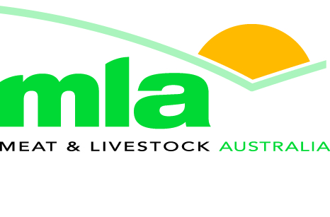
Regional Manager, Korea and Regional Manager, Middle East

- Challenging senior expatriate roles
- Based in Seoul, South Korea and Dubai, United Arab Emirates

Meat & Livestock Australia Limited (MLA) is a producer owned company responsible for marketing and research activities for the Australian red meat industries. MLA adds value to this $15 billion industry through the provision and delivery of innovative services and solutions.

We are currently seeking two Regional Managers to join our Global Marketing team in Seoul and Dubai. The successful applicants will lead a small team and provide strong leadership in areas of meat safety/issues management, improving market access and building demand for Australian red meat in the respective markets.

Reporting to the General Manager, you will be responsible for developing and implementing marketing programs; improving trade and consumer perceptions of Australian red-meat products; maintaining and improving market access conditions and fostering a close working relationship with government officials, meat industry and other organisations, key trade customer groups and individuals within the region.

To be successful for this role you will have:
- Tertiary qualifications in marketing, business or economics or extensive high level marketing experience.
- A broad knowledge of the Australian meat and livestock industry
- Demonstrated people leadership capability
- The ability to represent the industry’s interest at senior industry and government level
- An understanding of public sector organisations and government
- Extensive experience in trade and consumer marketing
- Demonstrated knowledge of the food export business, preferably meat
- Excellent communication and presentation skills

The successful applicants, and where applicable his/her immediate family must be excited about relocating to the respective regions for a term of three years. It is preferred that the applicants for the Regional Manager, Korea be fluent in the Korean language and experience with Korean business culture.

For a full position description please go to www.mla.com.au.

To apply for this position please email your application to careers@mla.com.au

For further information, please contact Bonita Haikalis on 02 9463 3333

Applications close: Noon 13 April 2012

