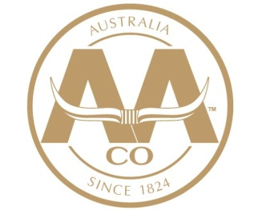

**Australian Agricultural Company Limited**

**Feedmill Leading Hand**

**Aronui Feedlot, QLD**

The Australian Agricultural Company (AACo) is the largest vertically integrated beef cattle producer and marketer in Australia, running over 650,000 head of cattle.

**AACo** is currently offering an opportunity for a **Leading Hand** to join the team at **Aronui Feedlot** which is situated on the Darling Downs, approximately 20 kilometres north of Dalby.

The position offers an excellent opportunity for a career pathway through AACo for future roles with higher levels of responsibility.

**We are looking for someone with the following attributes and skills:**

* Interested in systems and feed manufacturing
* Interested in intensive livestock feeding
* Milling and grain handling experience an advantage
* Effective leadership and teaching skills
* Natural self-motivation and well organised
* Knowledge of the requirements for teams to work efficiently and safely
* Basic computer skills
* Car Licence
* Machinery tickets an advantage

Progression within the Company is encouraged and professional development will be a part of your career with AACo.

Remuneration package, including on-property housing and other benefits, will be discussed during the interview process.

**Join AACo Today?** To apply, please submit your application at [www.aaco.com.au/people-careers/](http://www.aaco.com.au/people-careers/). To enquire, contact Jamie Raven on [aronuifeedmill@aaco.com.au](mailto:aronuifeedmill@aaco.com.au) or 07 4662 5200.